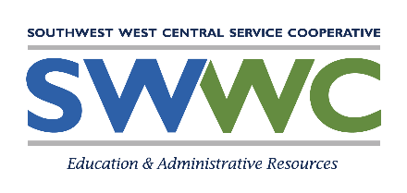
Special Education Advisory Council

The Southwest West Central Service Cooperative (SWWC) Special Education Advisory Council (SEAC):
- Advises the special education department on behalf of students receiving special education services.
- Provides opportunities for parents, staff, students, and community to share information and resources.
- Serves as an advocate for high-quality special education programs.

Members of the SWWC SEAC are volunteers to serve as representatives. The council consists of 7-10 individuals with at least 75% percent of the members being parents of students. One member will be the parent of a parentally placed private school student with disabilities (or an employee of a nonpublic school) if no parent of a nonpublic school student with a disability is available.

