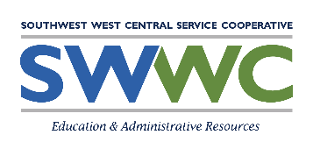
SWWC Trainer - Restrictive Procedures Training Form

Employee:
All Components listed on this form have been completed by the employee:
Restrictive Procedures Training Requirements
1. Positive behavioral interventions
2. Communicative intent of behaviors
3. Relationship building
4. Alternatives to restrictive procedures, including techniques to identify events and environmental factors that may escalate behavior
5. De-escalation methods
6. Standards for using restrictive procedures
7. Obtaining emergency medical assistance
8. Physiological and psychological impact of physical holding and seclusion
9. Monitoring and responding to a child’s physical signs of distress when physical holding is used
10. Recognizing the symptoms of and interventions that may cause positional asphyxia when physical holding is used.
11. District policies and procedures for timely reporting and documenting each incident involving use of a restricted procedure; and
12. School-wide programs on positive behavior strategies.

SWWC Trainer’s Signature: Date:

Employee’s Signature:

5/2017

